FACE MASK AND CONTACTLESS BODY TEMPERATURE DETECTION SYSTEM WITH EMAIL ALERT AND SMART-DOOR

Pallavi bonda

ECE

GVPCEW

18jg1a0470.pallavi@gvpcew.ac.in

**Abstract**

The Internet of things is one of the fields that have been used to provide remote monitors and control for the home appliances. In this project we implemented a Face mask and temperature detection system along with some additional features such as email alert and smart door locking and unlocking. If Face mask is put on and Temperature is below the threshold then the door will be unlocked. However, if Face mask is not worn or Temperature is above threshold then an email with a photo of the person with his body temperature will be sent to the concerned person.

# Keywords

IOT, Raspberry Pi, Face Mask, Temperature Detection, Door Lock, Email Alert

# Introduction

Since the corona outbreak, it has become very difficult to identify those who are affected by the virus or not. There are many temperature guns available in the market, but none of them gives any alert or email notification to higher authorities to take appropriate actions when the temperature exceeds a particular limit. Mandatory face mask rules are becoming more common in public settings around the world.

There is growing scientific evidence supporting the effectiveness of face mask wearing on reducing the spread of the virus. However, we have also seen some backlash on face masks, posing danger to people who are enforcing the rules. In some parts of the United States, they are often employees at the stores, as vulnerable as everyone else. One of the worst jobs in the world right now is being a greeter at a retail store who has to tell people to put on their face masks. Instead of making a human check for mask compliance,

We can create a Raspberry Pi-powered mask detector. Then unruly patrons can yell at a Raspberry Pi screen instead. To solve this issue, temperature devices are often used to measure body temperature. These devices have non-contact IR temperature sensors which can measure the body temperature without any physical contact. In this project, we will interface an IR temperature sensor to read body temperature, along with we will see if the person is without a mask if so then we will send the email alerts with the image of the person with his temperature of any person exceeding the set value.

1. **Design**

# .1 Hardware

* + 1. **Raspberry Pi**

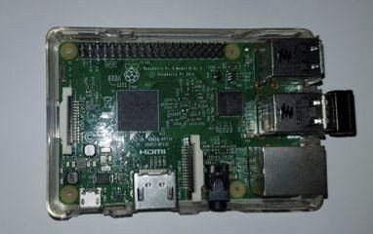

We have used Raspberry Module as our computation device which hosts our software and collects reading from attached peripherals and performs actions based on set condition. Processor speed ranges from 700 MHz to 1.4 GHz for the Pi 3 Model B+ or 1.5 GHz for the Pi 4; on-board memory ranges from 256 MiB to 1 [GiB](https://en.wikipedia.org/wiki/Gibibyte) random-access memory (RAM), with up to 4 GiB available on the Pi 4.

# Camera Module

Using an on-board webcam of the system. We can also use an external webcam for the system. It continuously captures the video and captures an image every 10 sec which is then sent to raspberry pi for further calculations.

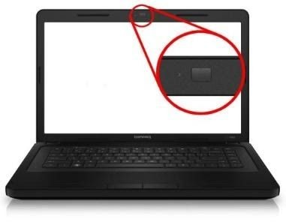

# Servo

A servomotor is a rotary actuator or linear actuator that allows for precise control of angular or linear position, velocity and acceleration. It consists of a suitable motor coupled to a sensor for position feedback. We have made use of the servo in order to control our door lock.

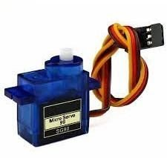

# 2.1.4 Display

We are using Display to show messages “You can proceed” with the mask and temperature is below Threshold. “Access Restricted” if the above condition turns to be false.

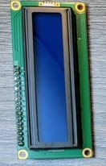

face mask and his body temperature is below threshold then Green light will turn on if not, then Red light will turn on.

. 

# Buzzer

If a Person is with a face mask and his body temperature is below threshold then the buzzer will buzz for one time or else it will buzz for three times.



# MLX90614 INFRARED THERMOMETER

We are using contactless IR temperature sensors to read body temperature. If the body temperature is above

38 then red led light will turn on, buzzer will beep for 3 times.

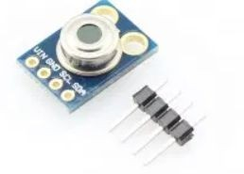

# 2 .2 Software and Libraries

**2.1.5 LED Lights**

We are using Red and Green light. If a Person is with a

# .1 OpenCV

OpenCV (*Open Source Computer Vision Library*) is a library of programming functions mainly aimed at real-time computer vision. We have used functions available in this library to implement our facial Recognition Part.

# .2 Python

Python is an interpreted, high-level, general-purpose programming language.Python's design philosophy emphasizes code readability with its notable use of significant whitespace. Its language constructs and object-oriented approach aim to help programmers write clear, logical code for small and large-scale projects. We have used this library to write our face recognition software

# .3 Tensorflow

TensorFlow is a free and open-source software library for machine learning. It can be used across a range of tasks but has a particular focus on training and inference of deep neural networks. TensorFlow is a symbolic math library based on dataflow and differentiable programming.

# .4 SMTP Email

SMTP is a Simple Mail Transfer Protocol which is an application layer protocol responsible for email service using TCP/IP. It provides the ability to send and receive e-mail messages and is managed by the Internet Engineering Task Force (IETF).

# Implementation

**3.2.3 SYSTEM FLOW**

In our project, firstly Face mask will be detected and results will be given to raspberry pi. Now the Temperature will be checked using contactless MLX90614 thermal sensor. Now, If Face mask is put on and Temperature is below the threshold then the green light will show and the buzzer will buzz for one time and the door will be unlocked. However, if Face mask is not worn or Temperature is above threshold then the red light will turn on ,the buzzer will buzz for three times ,and an email with a photo of the person with his body temperature will be sent to the concerned person.

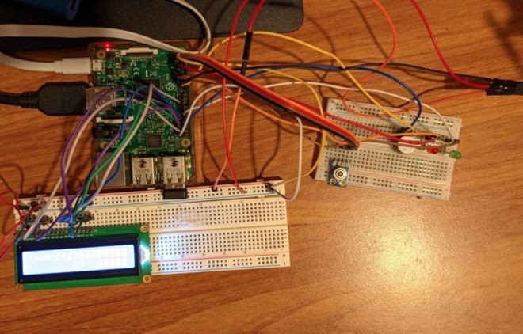

# .1 Face Mask Recognition

For face mask recognition we use Tensorflow and openCV libraries. Tensor-flow is an open library used for deep learning to build each layer in a convolution neural network. It offers multiple levels of abstraction to allow the user to choose the right facial features to determine the person. We trained the model using tensor-flow retrain which captures the essential differentiating features between the classes of images. The differentiating features are saved in the form of a graph. It is trained once and reused to classify the input images into categories for which it is trained. Later, this trained graph is used by the Image classification algorithm for authentication.

* 1. **.2 Contactless Temperature Detection** The MLX90614 is a non-contact infrared thermometer with a measurement range from -70 to +380 degree

Celsius. Just connect the four leads to your Arduino and you will have an accurate thermometer with a resolution of 0.01 and an accuracy of 0.5 degrees, or for that matter you can use any microcontroller that can communicate with it through it’s I2C interface.

Being an I2C device you simply need to connect to the SDA, SCL and choose a suitable GND and Vin. I used 3.3v.

# Conclusion

In this project, we have successfully implemented a prototype of a Face mask and body temperature detection-based door lock system. With the Hardware and Software requirements fulfilled it can be used in places with large gatherings like schools, entertainment halls, etc. The system first detects if a person is wearing a mask or not. The system is trained with tensor-flow and OpenCV libraries. It sends the result to raspberry pi on which the temp is checked and upon calculating the temp and mask it opens the door accordingly. we can improve the accuracy of the image classification model by adding more hidden layers and delimiting the false positives which would use more computational power which raspberry pi 3rd generation specifications may not fulfill, we can use cloud-based services to compute or train the model. As we are using a contactless temperature sensor, there is no need for a third person to stand there. The temperature sensor can be upgraded to more accuracy and length. Packing all the systems in one box makes it easy to carry anywhere and can be set up on-premise in no time.

In conclusion, Face Mask and body temperature detection can help us to reduce the large gathering of people in one place without masks, reducing the risk of getting infected.

# References

https://en.wikipedia.org/wiki/Raspberry_Pi#Model_B https://components101.com/sensors/melexis-mlx9061 4-contact-less-ir-temperature-sensor [https://www.tensorflow.org/tutorials/customization/cus](http://www.tensorflow.org/tutorials/customization/cus) tom_training_walkthrough https://en.wikipedia.org/wiki/Simple_Mail_Transfer_Pr otocol https://docs.opencv.org/master/db/d27/tutorial_py_tab le_of_contents_feature2d.html